1. Insertion sort:  
   -time best case: O(n)  
   -time worst case: O(n^2)

-space: O(1)

bubble sort:

-time best case: O(n)

-time worst case: O(n^2)

1. Insertion sort

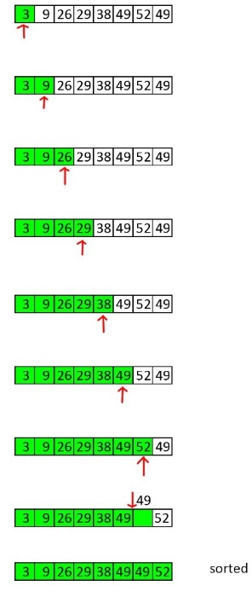

optimized bubble sort

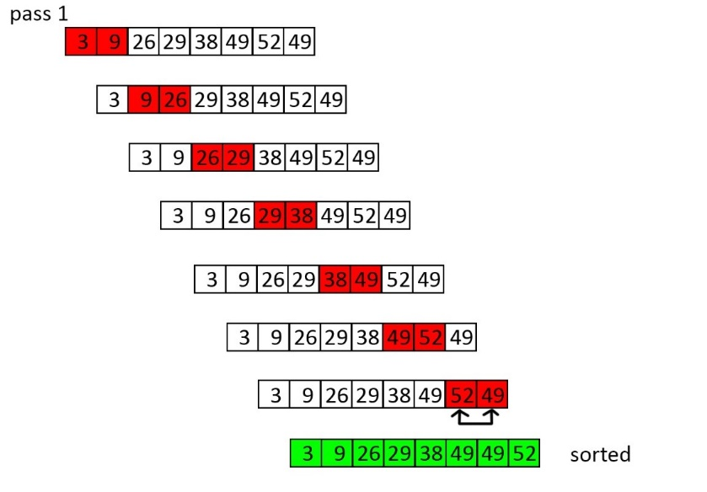

1. A. partially sorted data sets

Insertion sort takes longer than bubble sort on partially sorted data sets because it will check every number to the left of the current number even if it is already sorted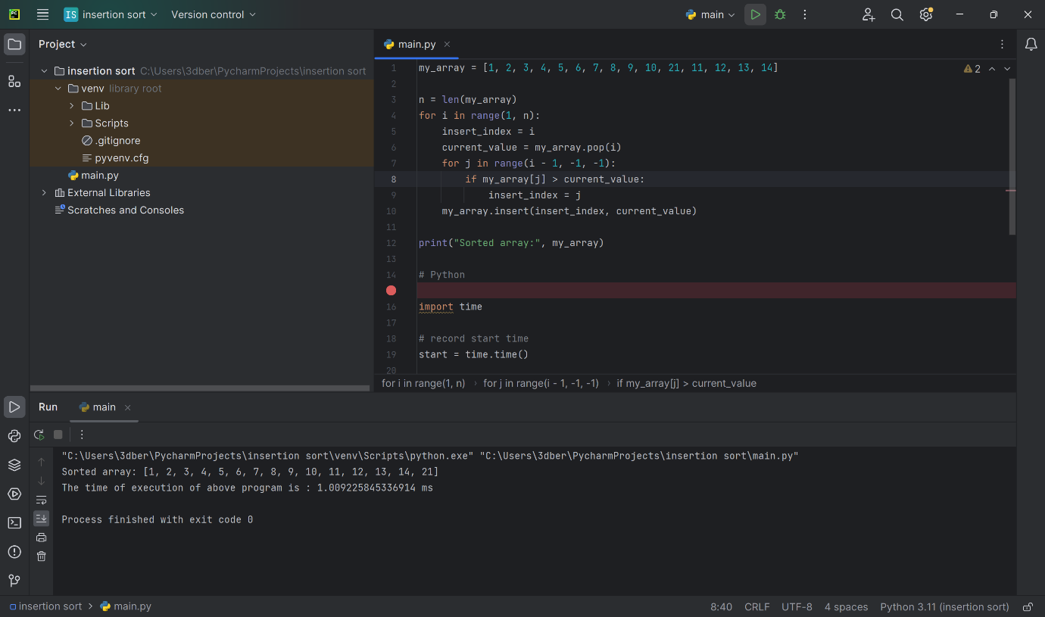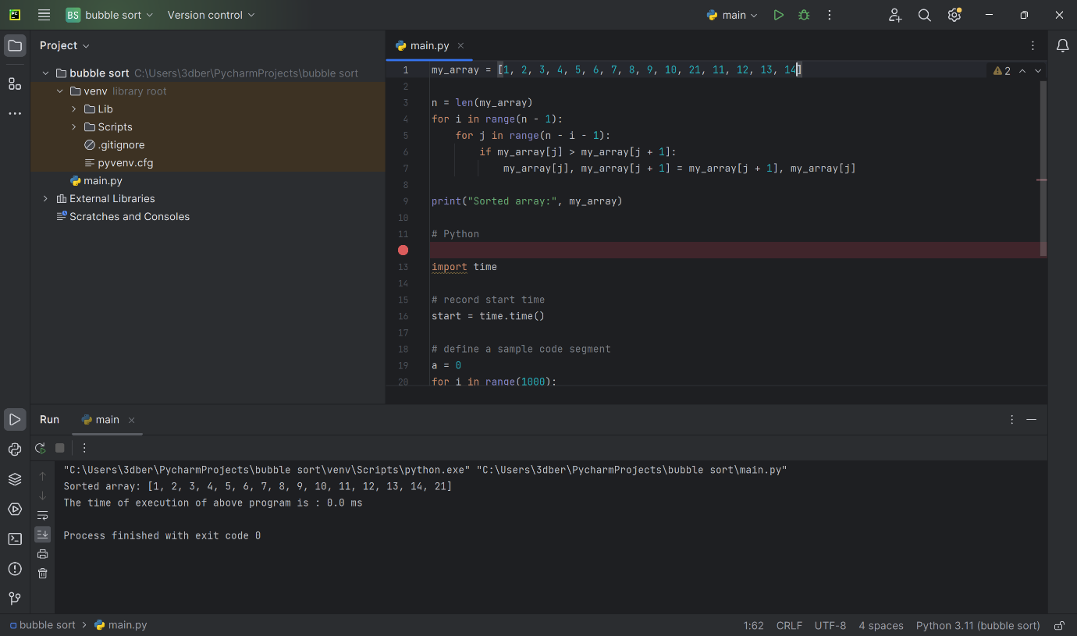

B. unsorted data sets

Insertion sort is better for unsorted data sets because it instantly puts the data in the correct place while bubble sort swaps which takes more time

